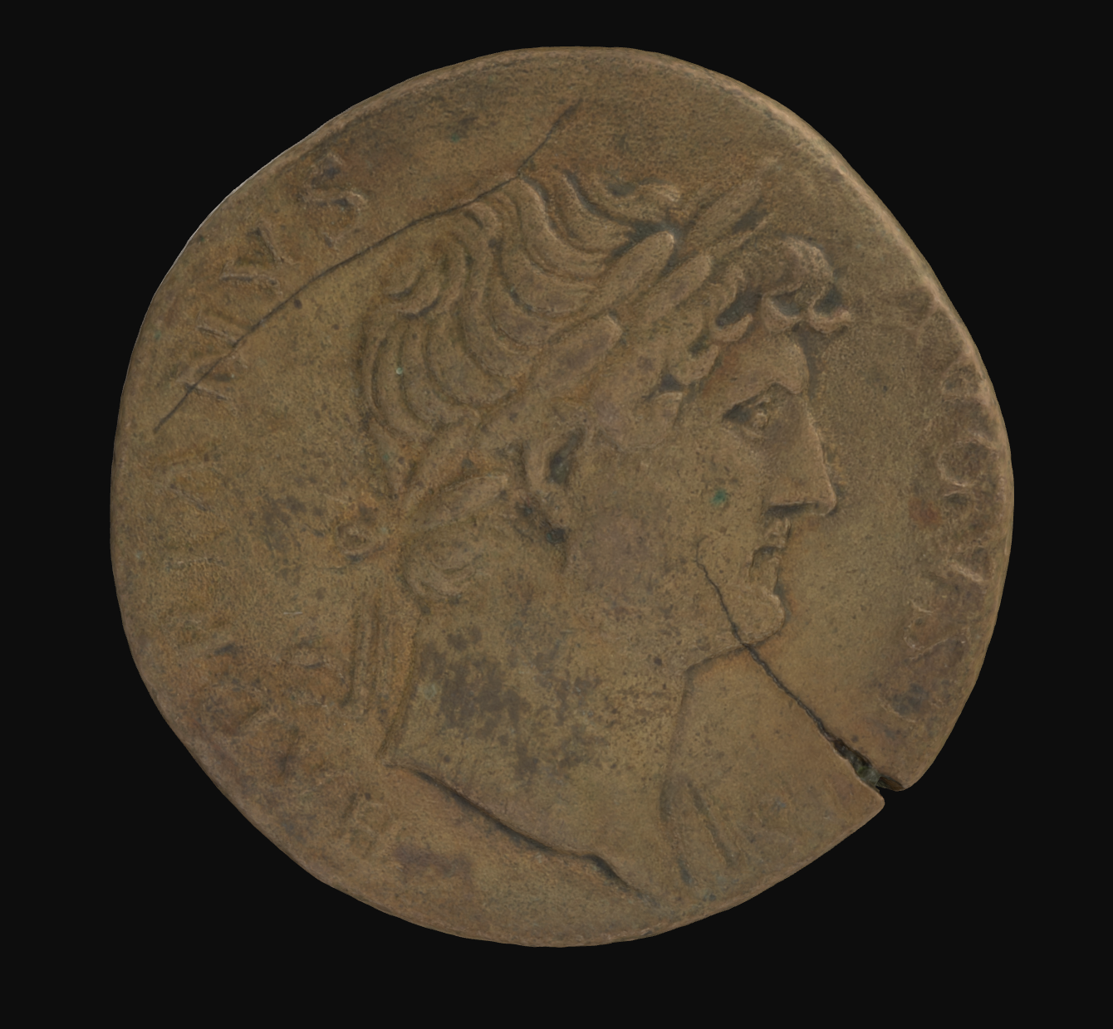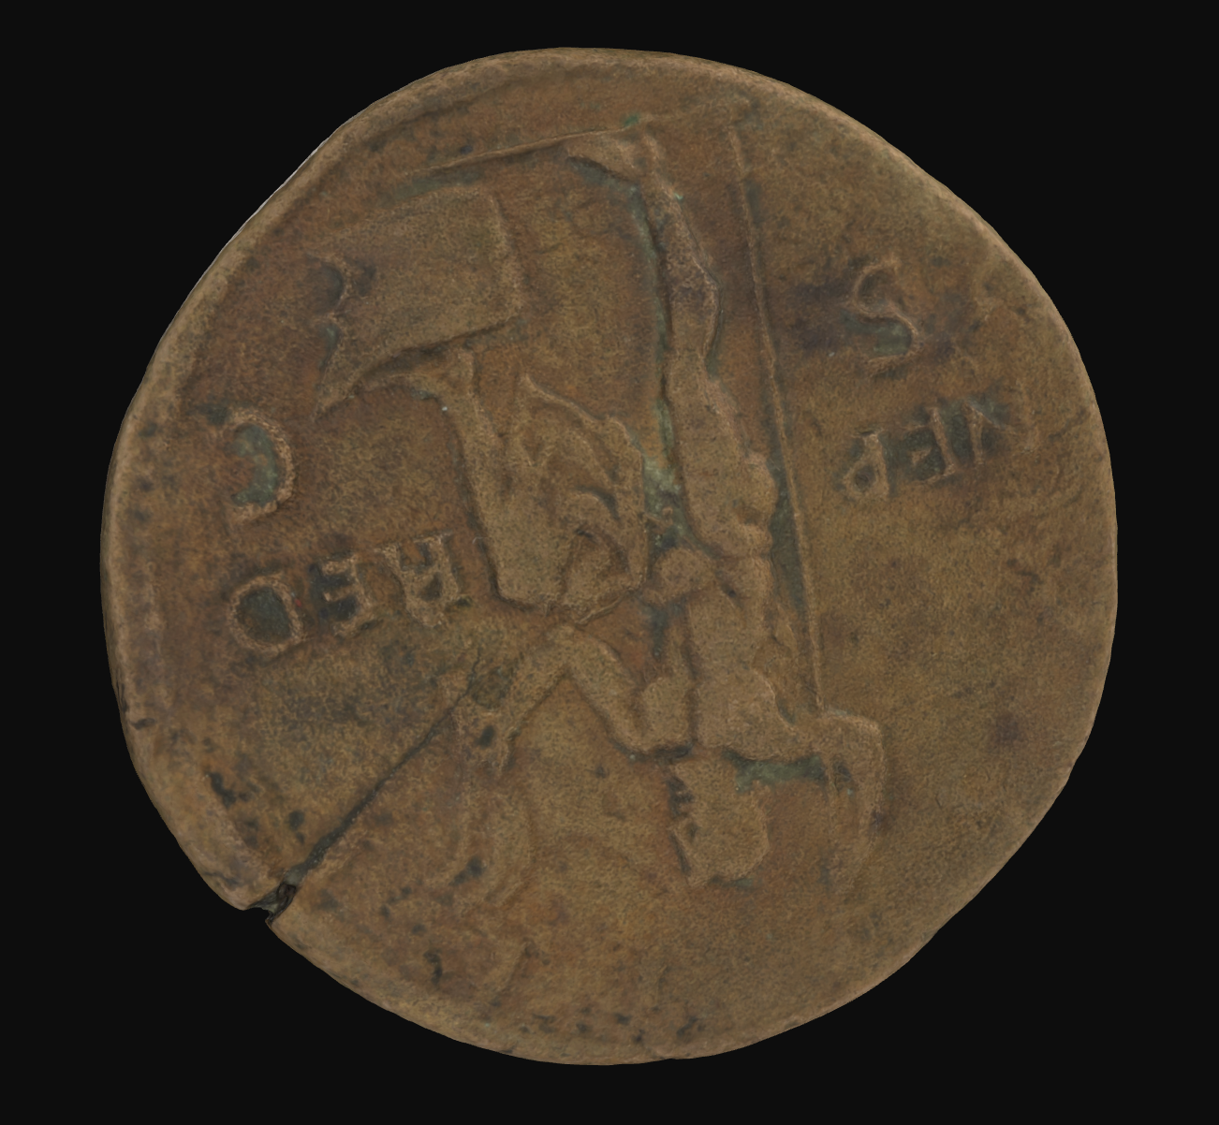

**Hadrian Sestertius:**

*This bronze sestertius (07GH258), issued by the emperor Hadrian, was minted in Rome between 125 and 128 CE. This period marks the short period in which he returned to the capital, after travelling through Western Europe, across the Mediterranean and through the Black Sea between 121 and 125 CE. The obverse of the coin depicts a laureate bust of Hadrian with drapery on his left shoulder. The inscription reads HADRIANVS AVGVSTVS. Hadrian, who was emperor from 117-138, rarely stayed in Rome itself, making an effort to travel to the provinces and consolidate the expansions made by his predecessor, Trajan. The reverse depicts Neptune standing with his left foot on a prow and cloak over his thigh, holding an acrostolium in his left hand and a trident in his right. The inscription reads NEP. RED. (Neptunus Redux) and S.C. (Senatus Consulto), with a possible faded inscription along the top of the coin reading COS. III (Consul Tertium), marking the emperor’s third consulship earlier in 119 CE. the coin commemorated Neptune, not only for Hadrian’s safe return to Rome, but also for allowing Romans continued safety on the Mediterranean Sea.***HADRIANVS AVGVSTVS: Pater Patrie of Travel Blogging (Part 1)**

The coinage of Emperor Hadrian is key in understanding the role of the Emperor in the provinces. During his travels, he issued many different coins, priding himself on his personal role in their development. His work emphasised the importance of the empire’s natural borders, reflecting his goal to consolidate the boundaries of Rome. As an ancient travel blogger, here is a timeline of his second journey, of which *07GH258* marks the end.

|  |  |
| --- | --- |
|  | **121 CE:** Checked in at *Gallia*.  “I’ve hit land! Docked at **Massilia**, before visiting **Lugdunum** in Gallia.Had a great time restoring theatres, forums, and a sanctuary for Augustus!” |
|  | **122 CE:** Checked in at *Germania*.  “Upgraded the Roman frontier along the Rhine River while visiting the legionary base at **Mogontiacum**. Check out the new artificial borders of the Empire!” |
|  | **122 CE:** Checked in at *Britannia.*  “Travelled up north from **Londinium** and devised plans to build a wall that spans the isle! Once it’s complete, our Empire will have a clear border. Visit if you get the chance!” |
|  | **123 CE:** Checked in at *Hispania*.  “Passed back through *Gallia* to visit my homeland, *Hispania* – especially the capital, **Tarraco**! What a refreshing stop before we cross the Mediterranean!” |
|  | **123 CE:** Checked in at *Asia*.  “Between docking in **Antioch**, traversing the *Parthian border*, and sailing across the Black Sea coast to **Nicomedia**, it’s been busy in the province of Asia!” |
|  | **124 CE:** Checked in at *Achaea.*  “I’m on the home stretch now! After visiting **Hadrianopolis**, the ancient **Troas**, and then **Ephesus** in Anatolia, I turned my sights onto **Athens**. Hellenic society always amazes!” |
|  | **125 CE:** Checked in at *Macedonia*.  “While in **Athens**, I participated in the Eleusinian Mysteries (it’s a secret!), and did a tour of the Peloponnese. I then travelled up Epirus to the Macedonian city of **Dyrrhachium**! |
|  | **125 CE:** Checked in at *Sicily*.  “Sailed from Macedonia straight to **Syracuse**. I’d always wanted to reach the top of Mt. Etna to behold the sunrise, and so I did just that!” |
|  | **125-128 CE:** Checked in at *Rome*.  “Home at last! I am back in **Rome** for now. We can only thank Neptune for my safe return, and the continued safety of us Romans in *mare nostrum*.” |

**HADRIANVS AVGVSTVS: Pater Patrie of Travel Blogging (Part 2)**

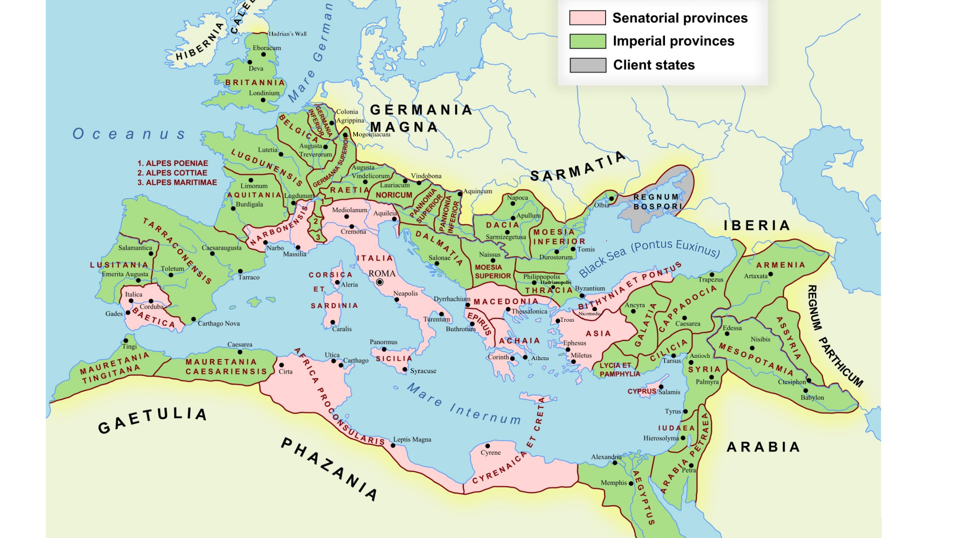Using the locations listed in Hadrian’s travel blog, plot out the direction of his journey across the Roman Empire from 121-125 CE by finding all the relevant cities! Remember that he must start and finish in Roma itself!